VSPF Stacked Filter Press
Equipment Introduction
VSPF stacked pressure filter is a kind of high-efficiency, energy-saving and intelligent solid-liquid separation equipment. It makes full use of the slurry feeding pump pressure, slurry properties and rubber diaphragm extrusion pressure, and use filter cloth as filter medium to separate the solid and liquid from slurry.

Equipment Features
● use stacked structure for the plates, use auxiliary guide device to make the operation become more stable.
● integrate filtering, extrusion, washing, air-drying, cake discharging and cloth washing together.
● the extrusion pressure up to 1.6MPa, it widely used in the field which has different requirements for cake moisture.
● 4.use hydraulic drive control system, make the operation stable and with low power consumption.
● integrate PLC, HMI and instruments control system etc. intelligent together, it makes filter more efficient and easier.
● use high pressure water cleaning device to make the cloth washing more effective.
● design with circular chamber, the structure more rational, the efficiency more prominent.

Operating Principle
- Filtering: when the plates group closed, pump the slurry to filter, use distributed hose to feeding slurry to each slurry chamber, and filtrate pass through the cloth to filtrate frame and discharge out, the solid formed a cake on cloth surface.
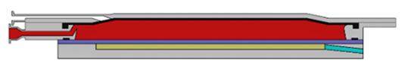

2、Extrusion: high pressure water fed into upper chamber of rubber diaphragm, make the diaphragm expand and extruding the cake and the liquid will be extruding out from cake.
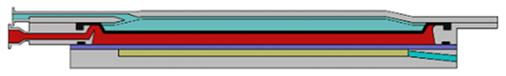
- Cake washing: washing water feeding into slurry chamber through distributed hose cover on the cake completely,under the pressure, the washing water pass through the cake and cloth to discharge out.
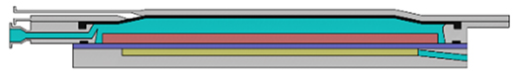

- Air drying: compressed air through distributed hose feeding into slurry chamber and pressing rubber diaphragm, make the high-pressure water in the rubber diaphragm to discharge out, and the compressed air pass through cake and take liquid out to decrease the cake moisture to the lowest level.
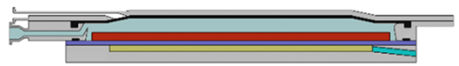

- Cake discharging: when finished the air-drying process, open the plates group, drive system makes the cloth running and the cake discharge out on the two sides of filter at the same time.
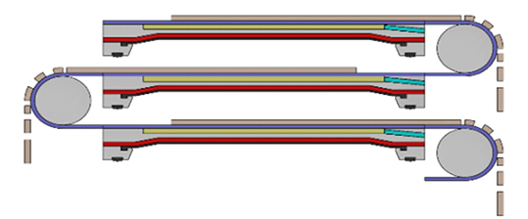

Note: Please according to the real using condition to adjust the times of extrusion and air- drying process.

Process Flow Diagram
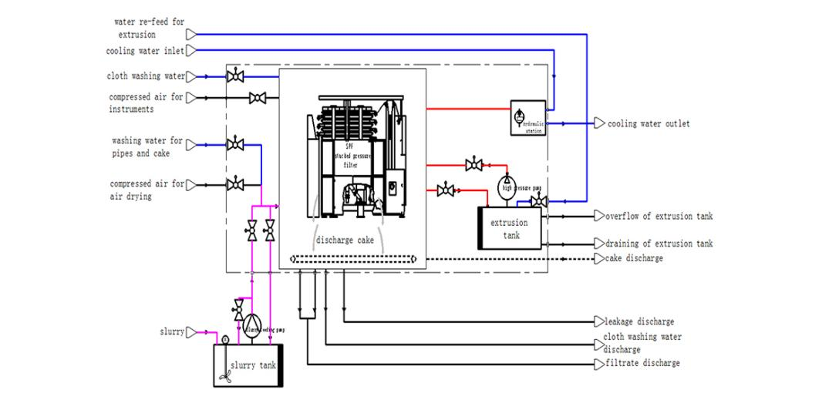

Equipment Series
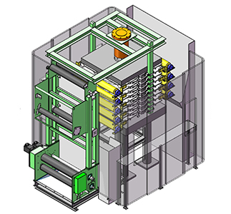 | 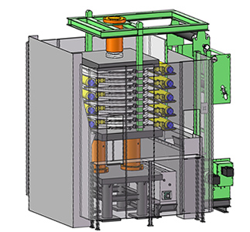 | 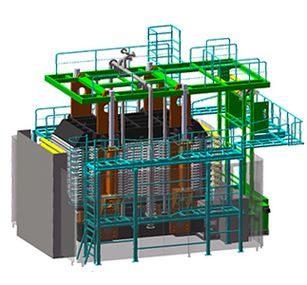
VSPFⅡ series | VSPFⅢ series | VSPFⅣ series

Technical Specification
Model/VSPFⅠ | VSPFⅠ-1 | VSPFⅠ-2 | VSPFⅠ-3
Filter area/m² | 1 | 2 | 3
Plate size/mm | 0.5m²/layer
Plate qty/layer | 2 | 4 | 6
Length/m | 2.5
Width/m | 1.5
Height/m | 2 | 2.2 | 2.5
Weight/T | 8 | 9 | 10
Hydraulic station power/KW | 7.5
Extrusion pump head/m | 167
Extrusion pump flowrate m³/h | 8
Extrusion pump power/KW | 7.5

Auxiliary Equipment Data
Pipe washing pump head/m | 70
Pipe washing pump flowrate m³/h | 10
Cloth washing pump head/m | 70
Cloth washing pump flowrate m³/h | 10
Slurry feeding pump head/m | 70
Slurry feeding pump flowrate m³/h | According to slurry data to choose
Air drying pressure/Mpa | 0.8
Air compressor flowrate for air drying m³/min | 0.5 | 1 | 1.5
Air drying tank volume/m³ | 1 | 2 | 3
Air pressure for instruments/Mpa | 0.7
Air compressor flowrate for instruments m³/min | 0.3
Instruments air tank volume/m³ | 0.5
Remark: the equipment outline dimension is basic size, but not details size, so this size just for reference. Different material of plate, the filter will have different height and weight. Auxiliary equipment data just for reference, it will change by filter performance in different slurry.

Technical Specification
Model | VSPFⅡ-3 | VSPFⅡ-6 | VSPFⅡ-9 | VSPFⅡ-12 | VSPFⅡ-15 | VSPFⅡ-18 | VSPFⅡ-21 | VSPFⅡ-24
filter area/m² | 3 | 6 | 9 | 12 | 15 | 18 | 21 | 24
plate size/mm | 1.5m2/layer
plate Qty/layer | 2 | 4 | 6 | 8 | 10 | 12 | 14 | 16
length/m | 3.7
width/m | 4.1
height/m | 2.6 | 2.8 | 3.2 | 3.7 | 4.2 | 4.6 | 5.1 | 5.5
weight/T | 12 | 13 | 14 | 15 | 16 | 17 | 18 | 19
hydraulic station power/KW | 11
Extrusion pump head/m | 28
Extrusion pump flowrate m³/h | 136 Note: if extrusion pressure more than 1.3MPa, this data is 164
Extrusion pump power/KW | 11 Note: if extrusion pressure more than 1.3MPa, this data is 15

Auxiliary Equipment Data
Pipe washing pump head /m | 68
Pipe washing pump flowrate m³/h | 20
Cloth washing pump head/m | 70
Cloth washing pump flowrate m³/h | 12
Slurry feeding pump head/m | 70
Slurry feeding pump flowrate m³/h | According to slurry data to choose
Air drying pressure/Mpa | 0.8
Air compressor flowrate for air drying m³/min | According to slurry data to choose
Air drying tank volume/m³ | 3 | 4 | 5 | 6 | 7 | 8 | 9 | 10
Air pressure for instruments/Mpa | 0.7
Air compressor flowrate for instruments m³/min | 0.5
Instruments air tank volume/m³ | 1
Remark: the equipment outline dimension is basic size, but not details size, so this size just for reference. Different material of plate, the filter will have different height and weight. Auxiliary equipment data just for reference, it will change by filter performance in different slurry.

Technical Specification
Model VSPFⅢ | VSPFⅢ-18 | VSPFⅢ-24 | VSPFⅢ-30 | VSPFⅢ-36 | VSPFⅢ-42 | VSPFⅢ-48 | VSPFⅢ-54 | VSPFⅢ-60 | VSPFⅢ-66
filter area/m² | 18 | 24 | 30 | 36 | 42 | 48 | 54 | 60 | 66
plate size/mm | 3.0m²/layer
plate Qty/layer | 6 | 8 | 10 | 12 | 14 | 16 | 18 | 20 | 22
length/m | 5.1
width/m | 5.5
height/m | 4.3 | 4.5 | 4.9 | 5.4 | 5.8 | 6.3 | 6.8 | 7.2 | 7.7
weight/T | 31 | 33 | 35 | 37 | 39 | 41 | 43 | 45 | 47
hydraulic station powerKW | 22
Extrusion pump head/m | 40 |  |  |  | 55
Extrusion pump flowrate m³/h | 136 Note: if extrusion pressure more than 1.3MPa, this data is 162 |  |  |  | 135 Note: if extrusion pressure more than 1.3MPa, this data is 166
Extrusion pump power/KW | 15 Note: if extrusion pressure more than 1.3MPa, this data is 18.5 |  |  |  | 22 Note: if extrusion pressure more than 1.3MPa, this data is 30

Auxiliary Equipment Data
Pipe washing pump head/m | 65
Pipe washing pump flowrate m³/h | 26
Cloth washing pump head/m | 70
Cloth washing pump flowrate m³/h | 16
Slurry feeding pump head/m | 70
Slurry feeding pump flowrate m³/h | According to slurry data to choose
Air drying pressure/Mpa | 0.8
Air compressor flowrate for air drying m³/min | According to slurry data to choose
Air drying tank volume/m³ | 8 | 10 | 10 | 12 | 12 | 15 | 15 | 20 | 20
Air pressure for instruments/Mpa | 0.7
Air compressor flowrate for instruments m³/min | 0.5
Instruments air tank volume/m³ | 1
Remark: the equipment outline dimension is basic size, but not details size, so this size just for reference. Different material of plate, the filter will have different height and weight. Auxiliary equipment data just for reference, it will change by filter performance in different slurry.

Technical Specification
Model VSPFⅣ | VSPFⅣ-60 | VSPFⅣ-72 | VSPFⅣ-84 | VSPFⅣ-96 | VSPFⅣ-108 | VSPFⅣ-120 | VSPFⅣ-132 | VSPFⅣ-144 | VSPFⅣ-156 | VSPFⅣ-168
filter area/m² | 60 | 72 | 84 | 96 | 108 | 120 | 132 | 144 | 156 | 168
plate size/mm | 6m²/layer
plate Qty/layer | 10 | 12 | 14 | 16 | 18 | 20 | 22 | 24 | 26 | 28
length/m | 7.1
width/m | 5.5
height/m | 5.4 | 5.8 | 6.2 | 6.6 | 6.9 | 7.2 | 7.6 | 7.9 | 8.3 | 8.6
weight/T | 92 | 96 | 100 | 104 | 108 | 112 | 116 | 120 | 124 | 128
hydraulic station power/KW | 30 |  |  |  |  |  |  | 37
Extrusion pump head/m | 110 |  |  |  |  |  |  | 150
Extrusion pump flowrate m³/h | 126 Note: if extrusion pressure more than 1.3MPa, this data is 168 |  |  |  |  |  |  | 128 Note: if extrusion pressure more than 1.3MPa, this data is 162.5
Extrusion pump power/KW | 37 Note: if extrusion pressure more than 1.3MPa, this data is 45 |  |  |  |  |  |  | 55 Note: > 1.3MPa, this data is 75

Auxiliary Equipment Data
Pipe washing pump head/m | 72
Pipe washing pump flowrate m³/h | 36
Cloth washing pump head/m | 70
Cloth washing pump flowrate m³/h | 20
Slurry feeding pump head/m | 70
Slurry feeding pump flowrate m³/h | According to slurry data to choose
Air drying pressure/Mpa | 0.8
Air compressor flowrate for air drying m³/min | According to slurry data to choose
Air drying tank volume/m³ | 20 | 20 | 25 | 30 | 35 | 35 | 40 | 40 | 45 | 45
Air pressure for instruments/Mpa | 0.7
Air compressor flowrate for instruments m³/min | 1
Instruments air tank volume/m³ | 2
Remark: the equipment outline dimension is basic size, but not details size, so this size just for reference. Different material of plate, the filter will have different height and weight. Auxiliary equipment data just for reference, it will change by filter performance in different slurry.

Application Fields
It is widely used in urban sewage, textile printing and dyeing, electroplate, papermaking, leather, brewing, food processing, coal washing, petrochemical industry, chemistry, metallurgy, mineral separation, pharmacy, ceramic industry sludge dewatering and so on, also use in industry production solid-liquid separation or liquid leaching process.

No. | Material name | Feed solidity (g/l) | Extrusion water ressure（MPa） | Cake thickness （mm） | Cake moisture （%） | Capacity kg/m².h
1 | 4A-zeolite | 150~295 | 1.4 | 35 | 19~22 | 190~200
2 | Sulfuret | ≈50 | 1.2 | 30 | 30 | 120
3 | Lead | ≈50 | 1.2 | 30 | 15~20 | 35
4 | Copper slag | 600 | 1.6 | 40 | 8~9 | 310
5 | Waste water sulphate | 80 | 1.6 | 45 | 28~35 | 120~175
6 | Calcination gold tailings | 300 | 1.6 | 35 | 14~18 | 300~340
7 | Superfine aluminum hydroxide | 15~20% | 1.6 | 20 | 29.5~32 | 65
8 | Cu-Ni concentration | 66.7 | 1.6 | 30 | 9.78 | 257
9 | Copper concentration | 45~50 | 1.6 | 35 | 7.6 | 360
10 | Ni concentration | 45~50 | 1.6 | 30 | 8 | 300~400
11 | Tantalum-niobium smelt |  | 1.6 |  | 20~25 | 200
12 | Coal slime | 30~35% | 1.6 | 30 | 16～17 | 300
13 | Slag iron | 40% | 1.6 | 28 | ≤9 | 280
14 | Gold tailings after flotation | 20~30% | 1.6 | 35 | 12~18 | 300
15 | Mannitol |  | 1.5 |  | 12 | 35
16 | Zinc oxide powder | 57% | 1.6 | 18 | 20 | 90
17 | Leaching residue of zinc oxide | 50% | 1.6 | 10 | 18~20 | 70
18 | Sulphur concentrate | 10% | 1.6 | 20 | 25~35 | 200

Equipment Structure
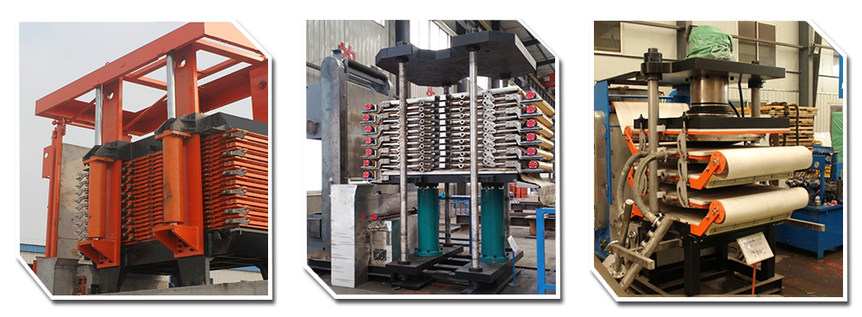

Plate Group Structure

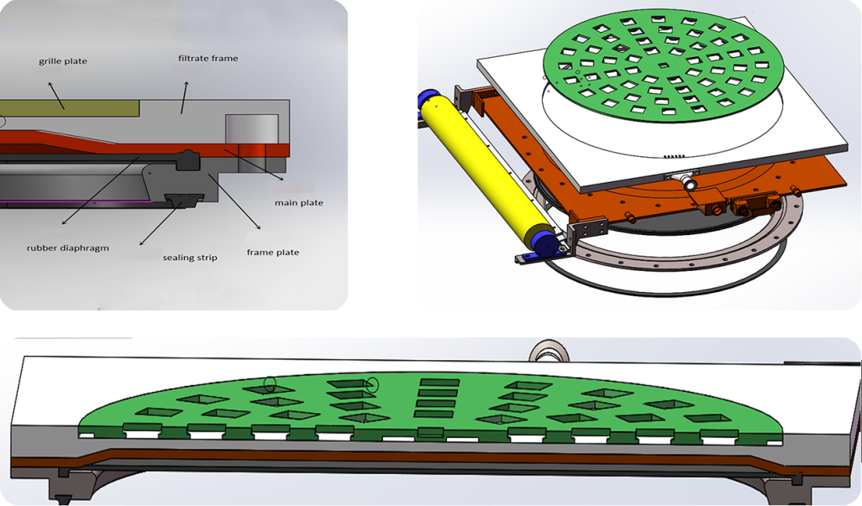

Manufacture Pictures

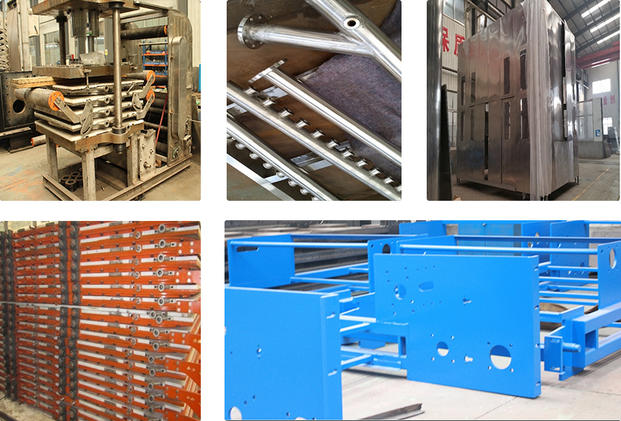

★ Main Parts

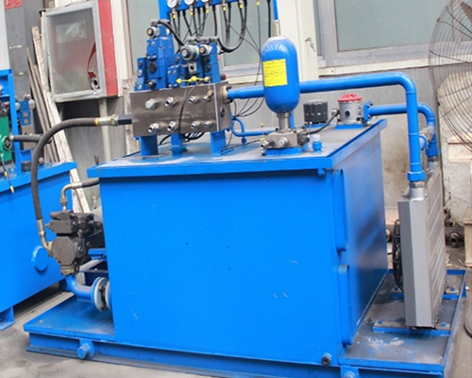 | 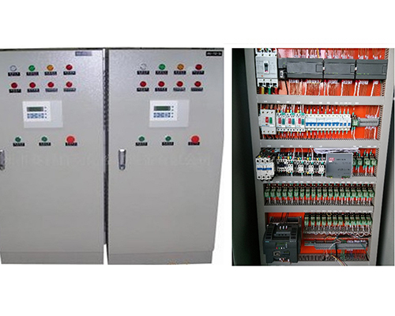
hydraulic system | control system
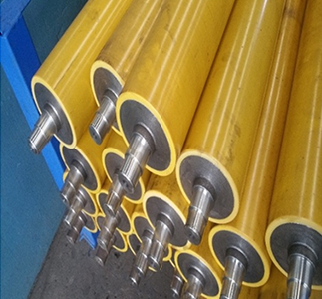 | 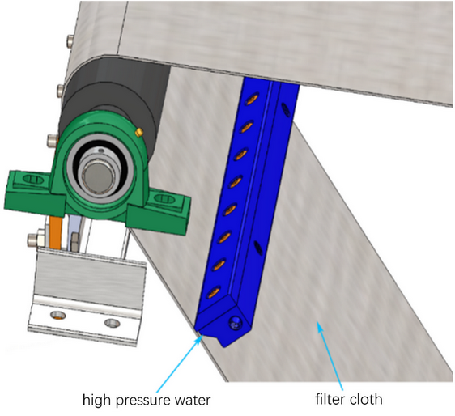
guide roller of plate | high pressure water washing device

★ Using Site

